r-pac International corporation
Global IT Team
EPC Module
customer epc logic and testing scripts

Contents

Centauro 2
Lacoste 4
Inditex 6
State of Art 7
Babyshop 9
C&A 11
Encuentro Moda 13
Kennedy Space Center 15
Moose Knuckles 17
Lindex 19
Diesel 20
MANGO 22
MANGO – Item Code: SSW 24
BlueFields 26
Alvaro Moreno 28
Gerry Weber 30
Stone Island 32

Centauro

Schema Type: SGTIN-96
Schema Info: Standard

Serial number start: 1000000.
Serial number end: 0

Serial Prefix:
Prefix length: 7 digits
Prefix Type:

Kill Password: NA
Access Password: NA

User Memory Logic: NA

Json Request & Response
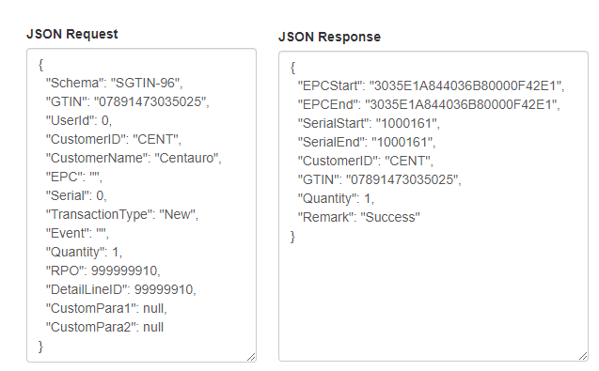

The affected tables are ‘tblEPCSerila’ and ‘tblEPCLog’

EPC Encoder/Decoder tool

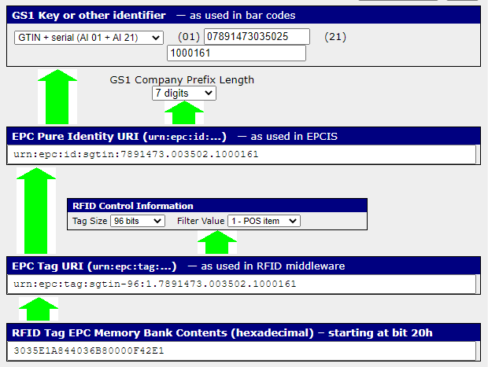

Lacoste

Schema Type: SGTIN-96
Schema Info: Standard

Serial number start: 20000000001.
Serial number end: 0

Serial Prefix:
Prefix length: 7 digits
Prefix Type:

Kill Password: NA
Access Password: NA

User Memory Logic: NA

Json Request & Response

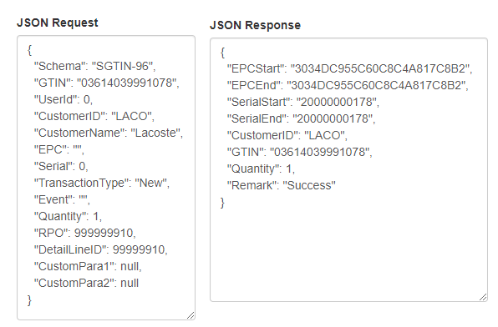

The affected tables are ‘tblEPCSerila’ and ‘tblEPCLog’

EPC Encoder/Decoder tool

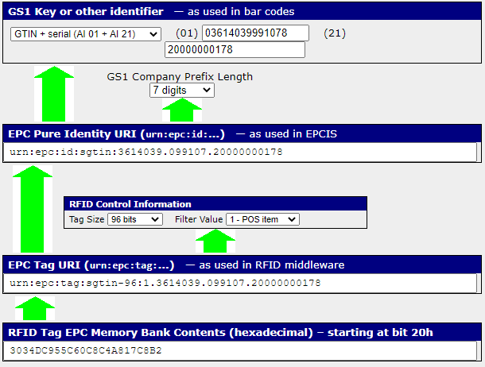

Inditex

Schema Type: SGTIN-96
Schema Info: We are using GTIN "00123456123456" for serial number increment.

Serial number start: 1500000.
Serial number end: 4294967295

Serial Prefix:
Prefix length:
Prefix Type:

Kill Password: 00000000
Access Password: 07F6D645

User Memory Logic: 00B77543

Json Request & Response

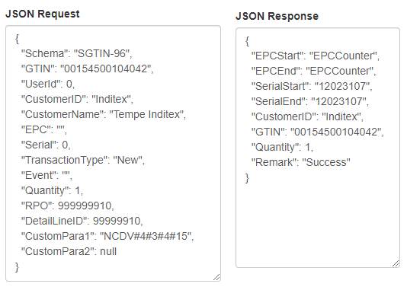

The affected tables are ‘tblEPCSerila’ , ‘tblEPCLog’ and ‘tblEPCCounter’

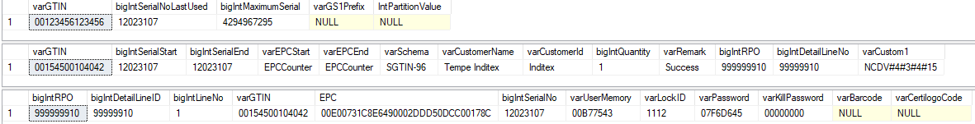

Please note that we are using GTIN "00123456123456" for serial number increment.

State of Art

Schema Type: SGTIN-96
Schema Info: Standard

Serial number start: 100000000000.
Serial number end: 0

Serial Prefix:
Prefix length: 7 digits
Prefix Type:

Kill Password: NA
Access Password: NA

User Memory Logic: NA

Json Request & Response

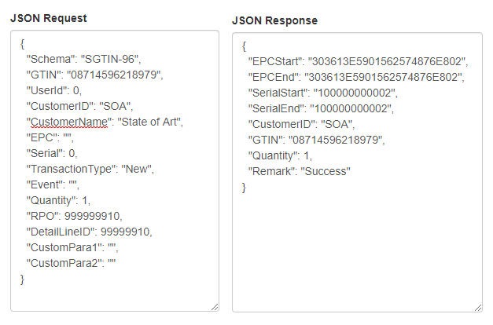

The affected tables are ‘tblEPCSerila’ and ‘tblEPCLog’

EPC Encoder/Decoder tool

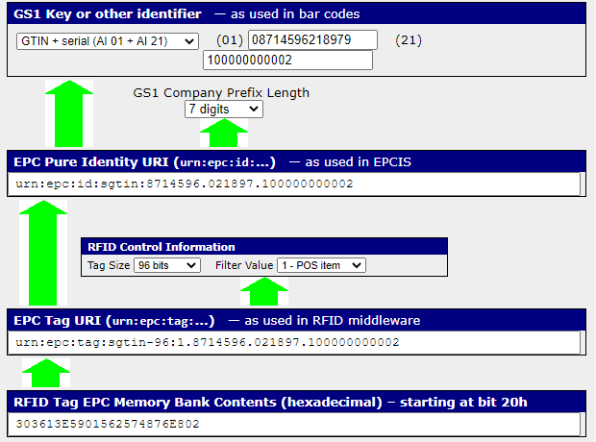

Babyshop

Schema Type: SGTIN-96
Schema Info: Prefix 4 is added to serial number (40000000000).

Serial number start: 0
Serial number end: 0

Serial Prefix: 40000000000
Prefix length: 6 digits
Prefix Type:

Kill Password: NA
Access Password: NA

User Memory Logic: NA

Json Request & Response
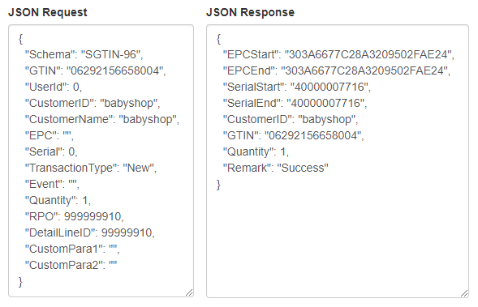

The affected tables are ‘tblEPCSerila’ and ‘tblEPCLog’

EPC Encoder/Decoder tool

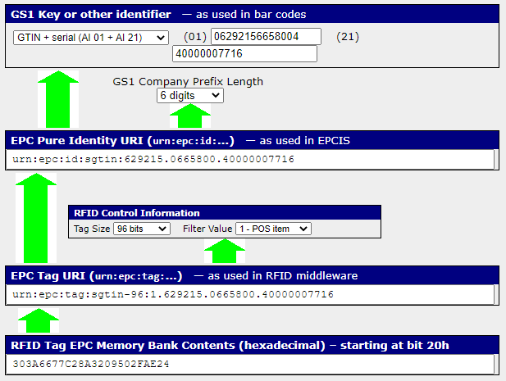

C&A
Schema Type: SGTIN-96
Schema Info: Standard

Serial number start: 8589934592.
Serial number end: 12884901887

Serial Prefix:
Prefix length: 7 digits
Prefix Type:

Kill Password: NA
Access Password: NA

User Memory Logic: NA

Json Request & Response
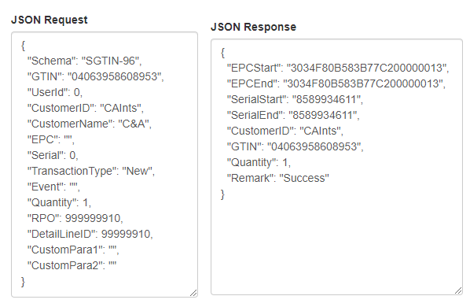

The affected tables are ‘tblEPCSerila’ and ‘tblEPCLog’

EPC Encoder/Decoder tool

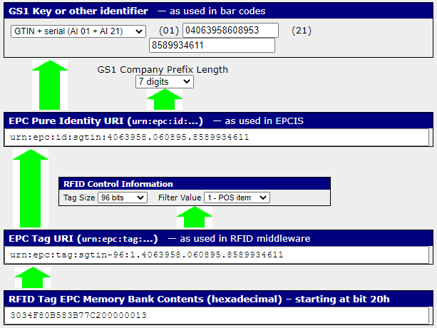

Encuentro Moda

Schema Type: SGTIN-96
Schema Info: Standard

Serial number start: 0
Serial number end: 0

Serial Prefix:
Prefix length: 7 digits
Prefix Type:

Kill Password: E411F96B
Access Password: 270C3E2F

User Memory Logic: 00000094

Json Request & Response
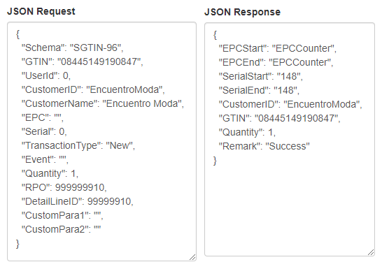

The affected tables are ‘tblEPCSerila’ , ‘tblEPCLog’ and ‘tblEPCCounter’

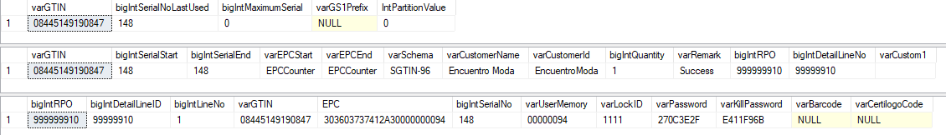

EPC Encoder/Decoder tool

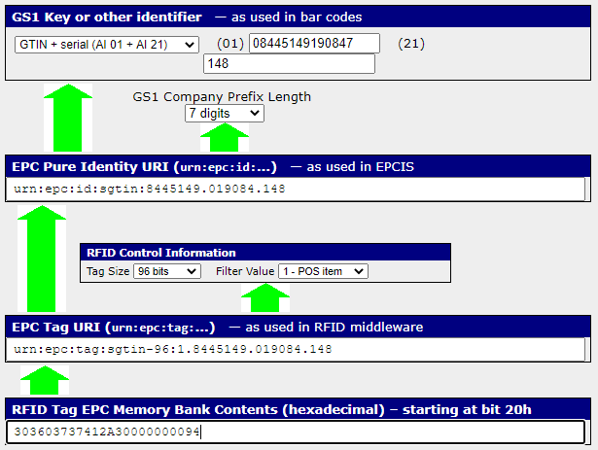

Kennedy Space Center

Schema Type: SGTIN-96
Schema Info: Standard

Serial number start: 0
Serial number end: 0

Serial Prefix:
Prefix length: 7 digits
Prefix Type:

Kill Password: NA
Access Password: NA

User Memory Logic: NA

Json Request & Response
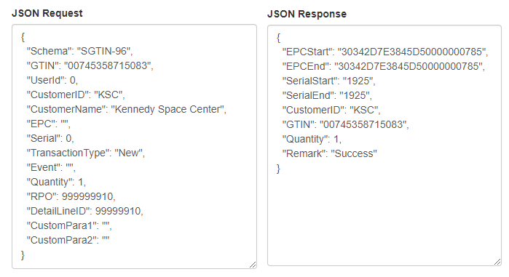

The affected tables are ‘tblEPCSerila’ and ‘tblEPCLog’

EPC Encoder/Decoder tool

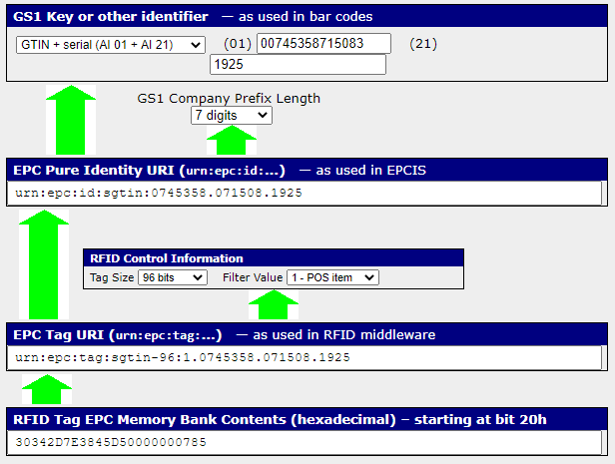

Moose Knuckles

Schema Type: SGTIN-96
Schema Info: Standard

Serial number start: 1000000
Serial number end: 0

Serial Prefix:
Prefix length: 7 digits
Prefix Type:

Kill Password: NA
Access Password: NA

User Memory Logic: NA

Json Request & Response
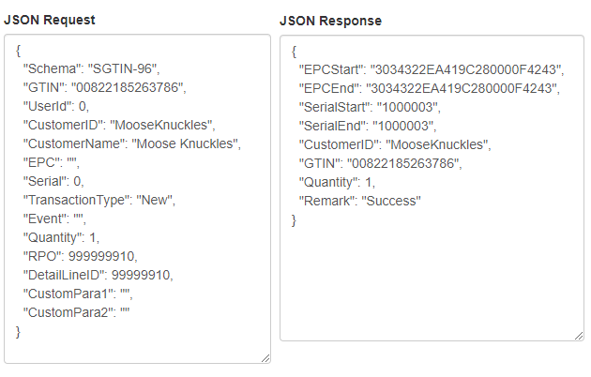

The affected tables are ‘tblEPCSerila’ and ‘tblEPCLog’

EPC Encoder/Decoder tool

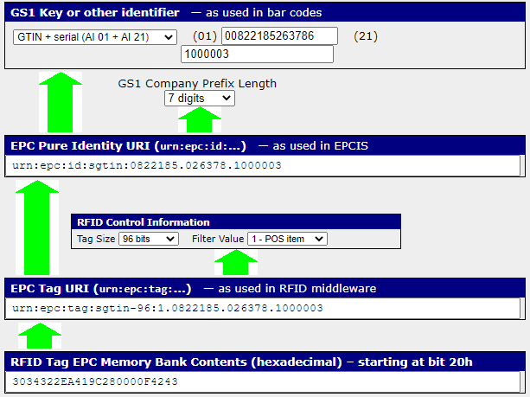

Lindex

Schema Type: SGTIN-96
Schema Info: We do not make any type of EPC. Only maintain serial number

Serial number start: 0
Serial number end: 9999999

Serial Prefix:
Prefix length:
Prefix Type:

Kill Password: NA
Access Password: NA

User Memory Logic: NA

Json Request & Response

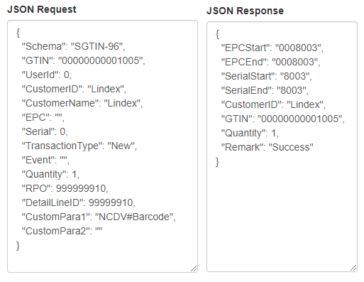

The affected tables are ‘tblEPCSerila’ and ‘tblEPCLog’

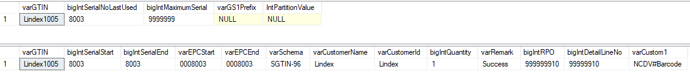

Diesel

Schema Type: SGTIN-96
Schema Info: Standard

Serial number start: 0
Serial number end: 0

Serial Prefix:
Prefix length: 7 digits
Prefix Type:

Kill Password: AB161A94
Access Password: EEDF1E78

User Memory Logic: 00000008

Json Request & Response
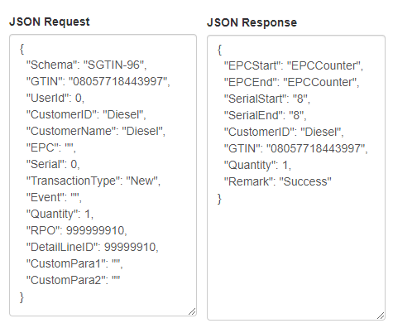

The affected tables are ‘tblEPCSerila’ , ‘tblEPCLog’ and ‘tblEPCCounter’

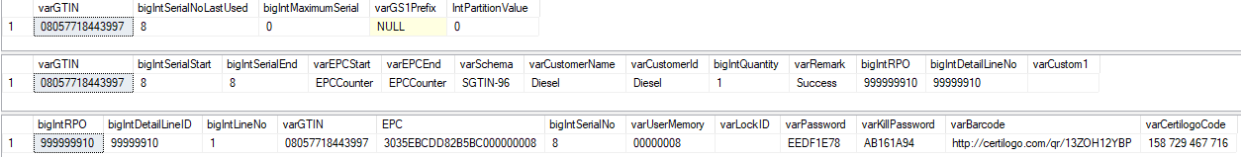

EPC Encoder/Decoder tool

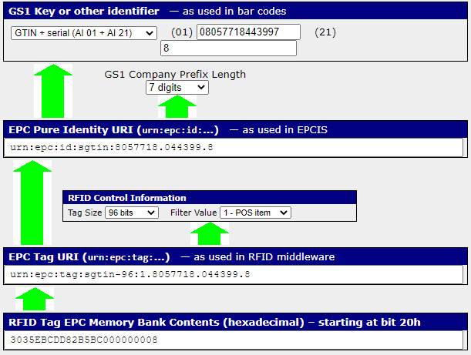

MANGO

Schema Type: SGTIN-96
Schema Info: Standard

Serial number start: 17280532480
Serial number end: 17314086911

Serial Prefix:
Prefix length: 7 digits
Prefix Type:

Kill Password: 88CF63EA
Access Password: C823FF44

User Memory Logic: NA

Json Request & Response
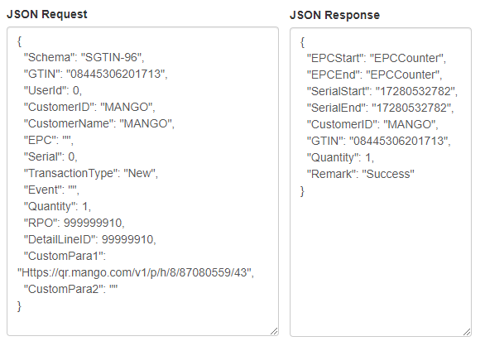
The affected tables are ‘tblEPCSerila’ , ‘tblEPCLog’,‘tblEPCCounter’ and ‘tblGS1CustomerDetail’

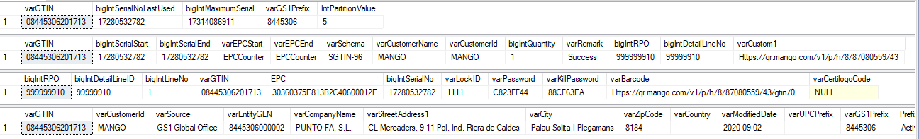

EPC Encoder/Decoder tool

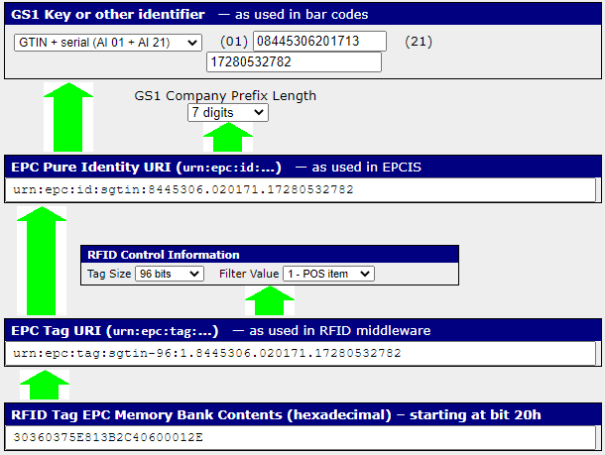

MANGO – Item Code: SSW

Schema Type: SGTIN-96
Schema Info: Standard

Serial number start: 51640270849
Serial number end: 51673825279

Serial Prefix:
Prefix length: 7 digits
Prefix Type:

Kill Password: NA
Access Password: NA

User Memory Logic: NA

Json Request & Response
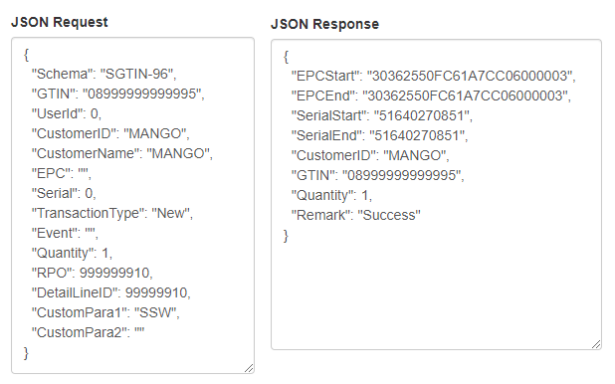

The affected tables are ‘tblEPCSerila’ , ‘tblEPCLog’ and ‘tblGS1CustomerDetail’

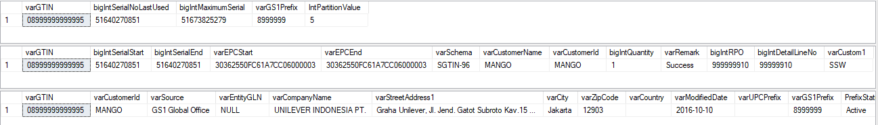

EPC Encoder/Decoder tool

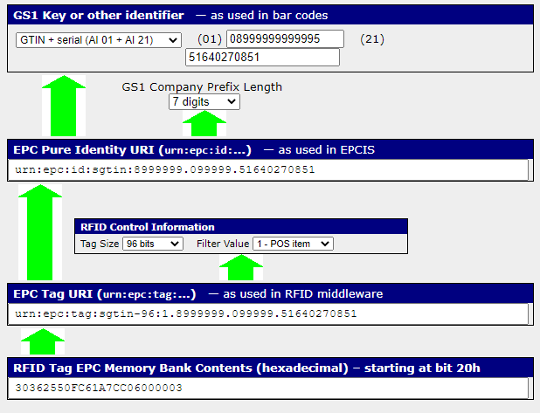

BlueFields

Schema Type: SGTIN-96
Schema Info: Standard

Serial number start: 100000000000
Serial number end: 0

Serial Prefix:
Prefix length: 7 digits
Prefix Type:

Kill Password: NA
Access Password: NA

User Memory Logic: NA

Json Request & Response
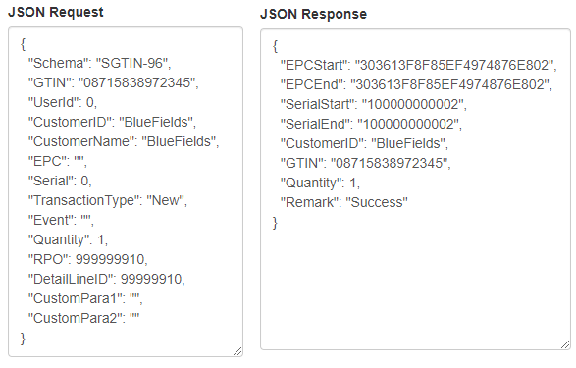

The affected tables are ‘tblEPCSerila’ and ‘tblEPCLog’

EPC Encoder/Decoder tool

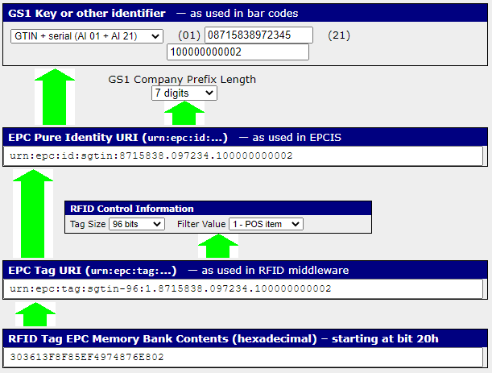

Alvaro Moreno

Schema Type: SGTIN-96
Schema Info: Standard

Serial number start: 1
Serial number end: 0

Serial Prefix:
Prefix length: 7 digits
Prefix Type:

Kill Password: EF83DA4D
Access Password: D8B0A01F

User Memory Logic: NA

Json Request & Response
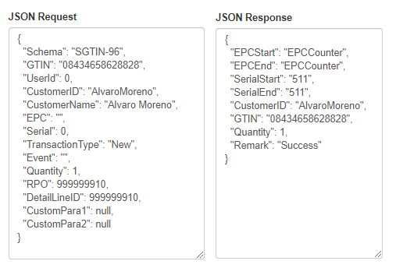
The affected tables are ‘tblEPCSerila’ , ‘tblEPCLog’,‘tblEPCCounter’ and ‘tblGS1CustomerDetail’

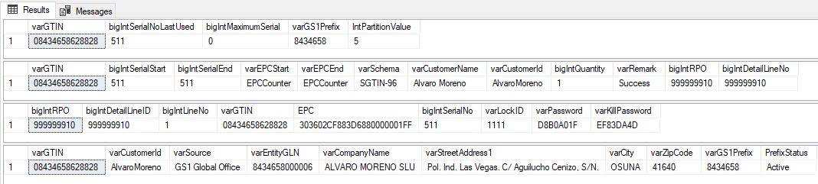

EPC Encoder/Decoder tool
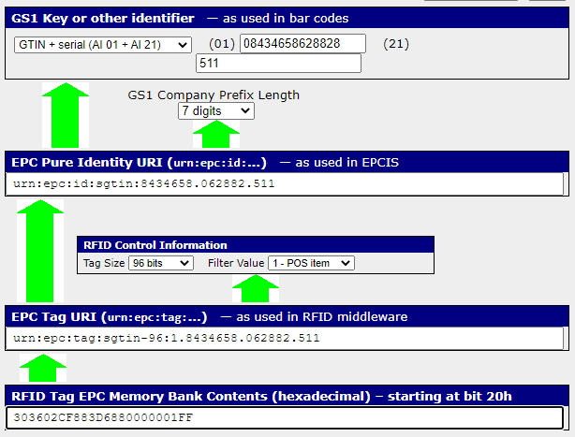

Gerry Weber

Schema Type: SGTIN-96
Schema Info: Standard

Serial number start: 1255103
Serial number end: 0

Serial Prefix:
Prefix length: 7 digits
Prefix Type:

Kill Password: NA
Access Password: NA

User Memory Logic: NA

Json Request & Response
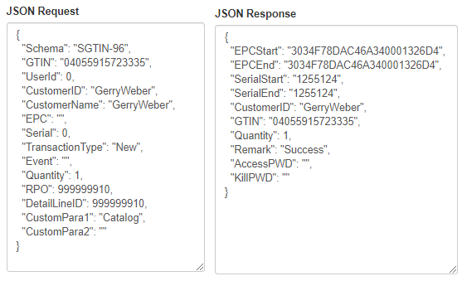
The affected tables are ‘tblEPCSerila’ , ‘tblEPCLog’

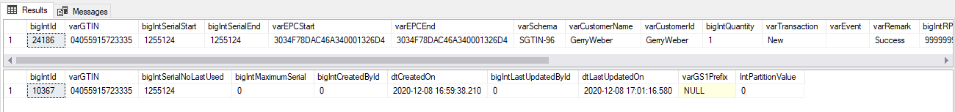

EPC Encoder/Decoder tool

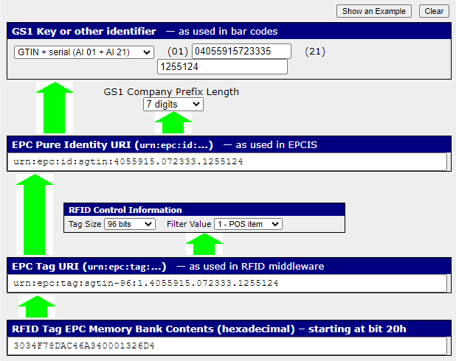

Stone Island

Schema Type: SGTIN-96
Schema Info: Standard

Serial number start: 0
Serial number end: 0

Serial Prefix:
Prefix length: 7 digits
Prefix Type:

Kill Password: NA
Access Password: NA

User Memory Logic: NA

Json Request & Response
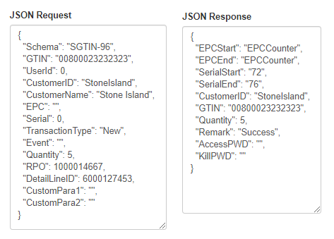
The affected tables are ‘tblEPCSerila’ , ‘tblEPCLog’ and ‘tblEPCCounter’

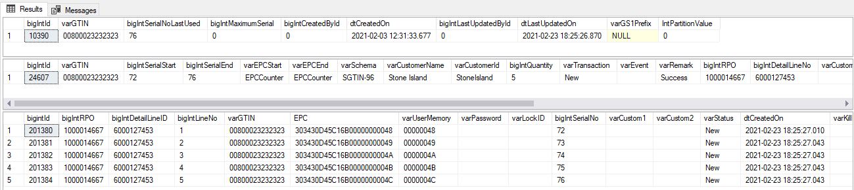

EPC Encoder/Decoder tool
